Now we already know how to spawn teh block in x or z direction Now we need to randomize teh spawning so it wither spawn in z or x randoimly
So we will do in this lesson
Now we create a new method called SpawnPlatforms
and this will actuaally take care of when the spawnx or spawnz happens So we can genrate a random number between two ranges(who knows) and when the number is between a certain range we can generate the spawnX and if it is another raange then we spawn spawnZ
So we create a random number by using Random.Range(lower number,
Higher number)
To keep uit to 50-50 so that there will be fair chances in spawnx and spawnz so we choose number upto 6 and store in rand variable So we write
Now we check if the rand<3 then we simply call the spawnX function or if the rand is greater than 3
or else call terh spawnZ

void SpawnPlatforms()

{
int rand = Random.Range(0, 6);
if( rand < 3)
{
SpawnX();
}
else
{
SpawnZ();
}
}

Now to test it we call it inside a lopp of 20 times which is inside start method Lets check it if it has a problem then we willl randomize it more(who knows)

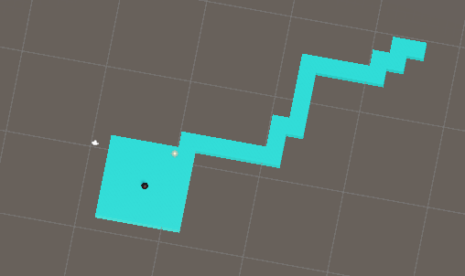
So now above you can see that it has generated some random paths
Now everytime we run it we geta random path as shown below

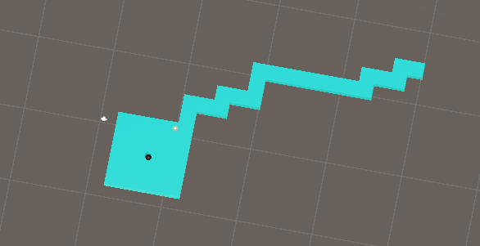
So we have created a randomisation algorithm
So after we call the spawnPlatform method 20 times then we need to called this spawnPlatform functoin repeatedly everytime after a few seconds so that it gets frequently called and new platofrm will get generated again and again So after doing this we will say invokeRepeating and through this we want to call spawnPlatform first time after 2 second and then call it repeatedly after every 0.2 seconds

6:04

Now you will see after creating 20 random platforms and after 2 second it will start creating random platform after every 0.2 seconds and it never stops

So we need to figure it stop it

so the same way we have done before we create another public bool variable and name it as gameOver

and now this variable will decide when the platform will be created and will not be created
Now in Update method you pur teh gameStart variable in condition and when the game start happens to be true then we will call CancelInvoke("Method name to stop there repeated execution after some time")

void Update()
{
if (gameOver) {
CancelInvoke("SpawnPlatforms");
}
}

Since the game start we can control its value in the inspector panel and can stop teh production of platforms in run time by checking the checkbox associated with gameOver

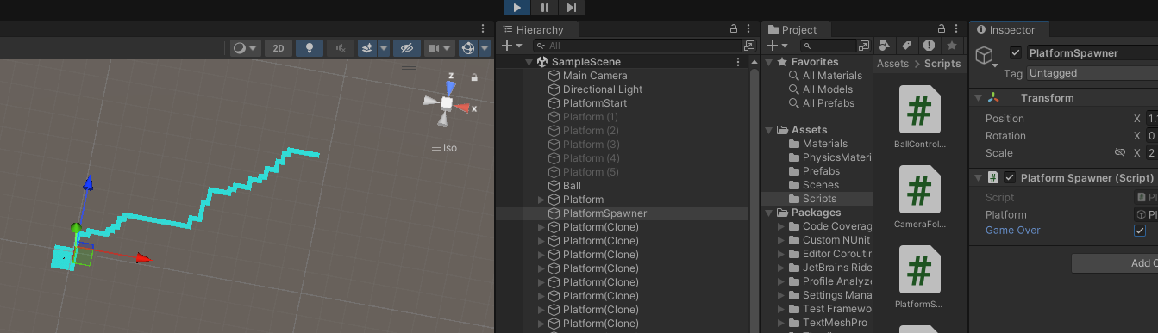
so we have created a mechanism to randomly generate a new platform and also to stop them whenever we want
So in the next lesson we will see many things

